What’s Crackin’?
Matzah Crack!
Recipe by: Ava Stills

Number of Servings:  1 full 13x18 cookie sheet (exact number depends on how you break up pieces)  Ingredients:  - 5 pieces, unsalted gluten-free matzah  - 2, ½ cup sticks (113 g) of salted butter  - 1 cup (198 g) firmly packed brown sugar | Personal Commentary:  Everyone has that something special they make around the holidays, my family used to make toffeed nuts! They were spicy and delicious but too much work, so for the past few years we started making matzah crack, a buttery, crispy, tasty toffee! Its quick and easy and will be gone in a blink!
Instructions:  - Preheat oven to 375º  - Line cookie sheet completely with tin foil  - Cover tin foil with parchment paper  - Line the sheets of matzah on the cookie sheet, breaking pieces to fill in holes as needed  - In a medium pot combine all of the butter and brown sugar  - Heat the pot on medium, stirring constantly, for 4 minutes, until the mixture boils  - Once boiling continue to stir the liquid for 3 more minutes  - After those 3 minutes, pour the mixture over the matzah in a back and forth motion  - Spread the mixture to completely and evenly coat the matzah pieces  - Reduce the heat to 350º and place the sheet in the oven  - Bake for 15 minutes  - After 15 minutes take the matzah out and let it cool for 30 minutes  - Break up the pieces and enjoy! | Helpful Hints:  - Have a second pair of hands to help you spread the mixture while you pour it.  - There will be lots of crumbs from breaking the pieces, have a small container to put them in for quick and little snacking!  Your toffee should look like this once you take it out of the oven:  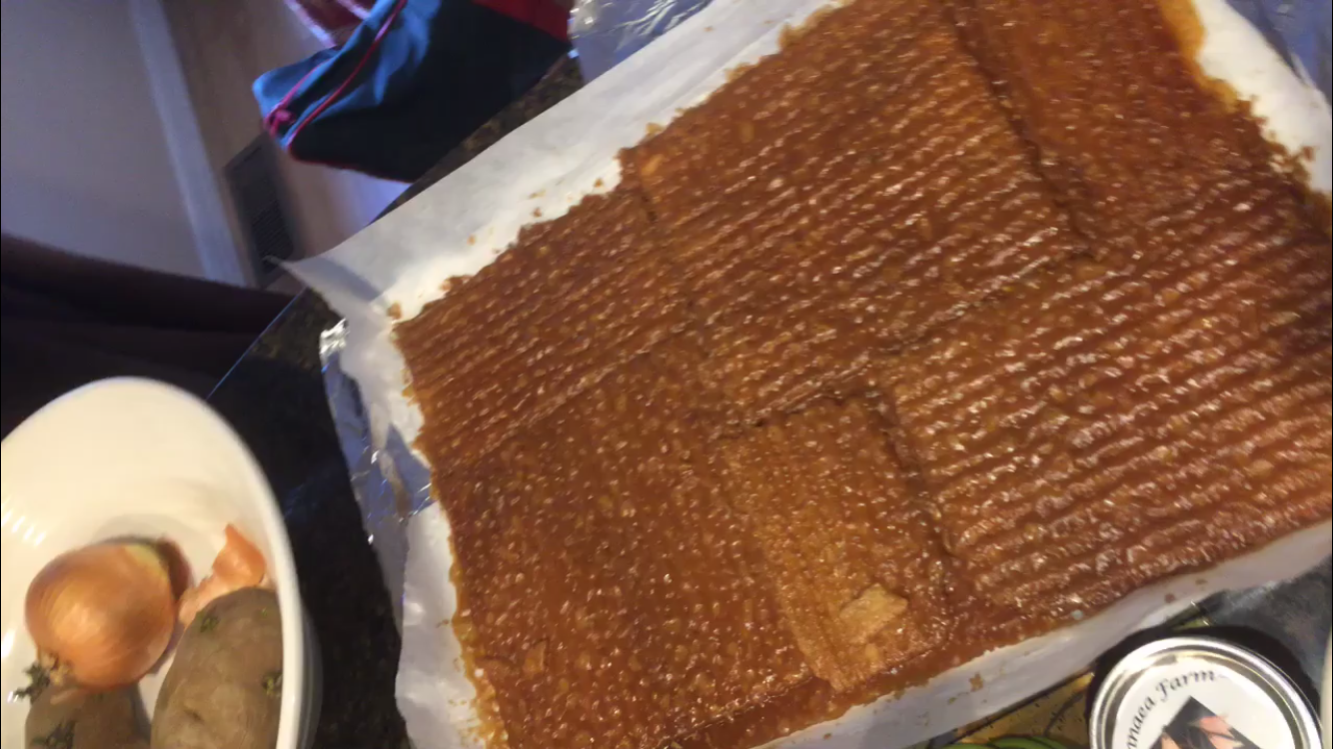
Experiment:  For this experiment I altered the fat in the recipe. The original recipe calls for butter as the fat, I chose to substitute the butter for ghee and coconut oil. The conversion factor for butter to ghee and butter to coconut oil was a 1 to 1 ratio. Which meant I used 1 cup of ghee or coconut oil instead of 1 cup of butter.  With these changes to the recipe I noticed that the fat substitutes both did not fully bond with the sugar to create one full mixture. The oils remained separated from the sugar leaving the matzah very greasy once coated. Also, neither the ghee or coconut oil mixture boiled. I conducted this experiment multiple times, once testing with the cooking time of the normal recipe and once with trying to get them to boil. In both of the trials the mixtures never boiled. The ghee simply burnt, as did the coconut oil eventually.  I personally do not recommend using these substitutes in matzah crack. The flavors ended up tasting burnt or very bitter. I highly recommend using butter as the fat in this recipe. | Why This Works:  Adding fats in candy making helps to prevent crystallization of the sucrose. Toffee is categorized as a non crystalline, which means the recipes for toffee are designed specifically to combat crystallization. Fatty ingredients prevent the crystallization of the sucrose, hence the role of butter in toffee. The crystal forms are made out of tight packed, orderly molecules.  As the sugar molecules attempt to bond into their crystalline structure, the fats interfere and prevent the bonding. The coconut oil and ghee did not bond with the sugar the way the butter sis, this left the “crack” crispy and much more greasy. It seems without the milk fat, like the butter has, the other two fats did not fully bond with the sugar.
Results:  From this experiment I ended up with three very different toffees. I had my classmates participate in a blind taste test to give me feedback on my crack. I tested sweetness, greasiness, and preference among other factors. From the results it is obvious that the original recipe matzah crack was by far the best. It was the least greasy, the sweetest, and most people ranked it as their most prefered. | Ghee matzah crack while cooking:  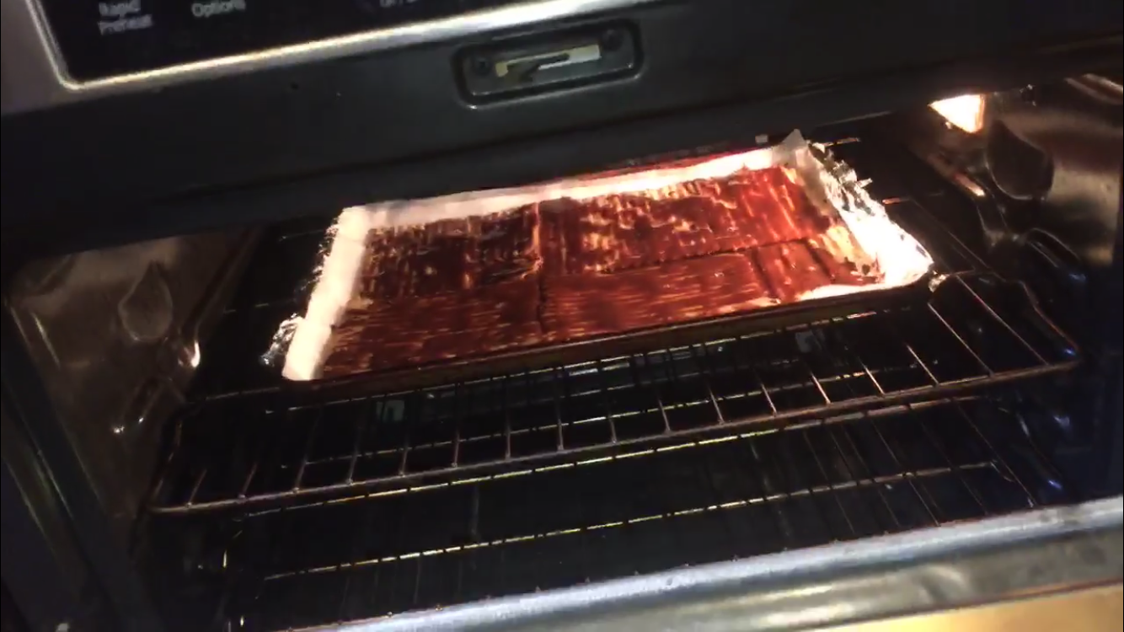
Good luck in your matzah crack adventures and enjoy!

